Exploring
Generative Relationships S T A R
Copyright 1998 - Brenda J. Zimmerman, York University
- for full journal article - please see:
- Zimmerman, Brenda J. and Bryan C. Hayday, “A Board’s Journey Into Complexity Science”, Group Decision Making and Negotiation, vol 8,
- pp. 281-303, 1999

A generative relationship “produces new sources of value which cannot be foreseen in advance” (Lane and Maxfield, 1996, pg. 215).
There are two key components to this definition. The first is that the relationship produces something, which one of the members of the relationship could not have produced alone. Second, the source of value (whether it be a new product, service, form of distribution or idea) could not have been foreseen in advance. It was created by the interaction between the parties.
Joint ventures may or may not be generative relationships. Often, they are merely partners who know what needs to be done a priori but each have a gap or deficiency which can be addressed by the other joint venture partner(s). Although this satisfies the first criterion of generative relationships, the source of value was foreseen in advance.
In complex contexts, where the future is inherently unknowable because the industry is going through transformational change, generative relationships are important. They allow the parties to learn as they co-create a new product, service, distribution process or solution.
Generative relationships have the capacity to deal with complex contexts where change is happening both at the level of structure (e.g., who are the players in the industry) and at a conceptual level (e.g., the definitions of the product or service). The story of ROLM and the PBX (internal telephone systems) is an example of how quickly a whole industry can shift when a product is reconceived as a voice-interface management tool rather than a “telephone”. Suddenly, computer manufacturers were key competitors to telephone giants like ATT. ROLM fostered generative relationships to thrive in this environment which they co-created.
How do you know whether a relationship will be generative or not? How do you enhance the generative potential of existing relationships? In an action research project with a nonprofit social service agency, which struggled with this concept, Zimmerman and Hayday (1999) used a four pointed star to demonstrate the dimensions of a generative relationship. They used the acronym of STAR to make the idea memorable. The next few pages define and describe the acronym with suggestions for practical applications.
Complex contexts call for relationships which can generate novel solutions.
Relationships with more generative potential are seen to have longer points on the generative relationship STAR (Zimmerman and Hayday, 1999). Each point of the STAR represents one key aspect of generative relationships.
Each point of the STAR represents one key aspect of generative relationships.
S Separateness or differences. There need to be differences in the background, skills, perspectives, or training of the parties. If all of the parties are similar, they may enjoy heated debates but may leave untouched or unchallenged the assumptions upon which both sides of the argument are based. You cannot challenge an assumption, which goes unnoticed. Differences allow the partners or group to see things from a different perspective. They allow “facts” to be seen as “interpretations”.
T Talking and listening (“tuning”). There needs to be real opportunities to talk and listen to each other with permission to challenge the status quo, sacred cows or implicit assumptions of the context. The conceptual changes in a complex context can be profound. Opportunities for reflection allow the parties to grow and learn.
A Action opportunities. Talk is great but unless it is accompanied by acting on the talk, new sources of value will not be created. The parties need to be able to act together to co-create something new.
R Reason to work together. The parties need to have a reason to share resources, ideas or to act as allies even if only for a short period. There has to be some mutual benefit to being aligned in a project. if the parties do not see value in working together, if they see each other as adversaries only rather than as allies for this piece of work, it is highly unlikely that they will co-create something of substantial value. They may talk and learn from each other, but then do the work of creating something new alone.
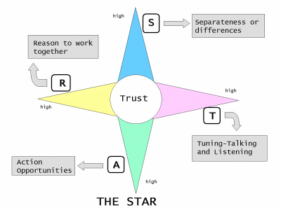

S and T are necessary to enhance the capacity to generate unforseen insights and sources of value. S and T operate primarily at the conceptual level. It is through redefining a “fact” or challenging an implicit assumption that new ideas can be created. A and R operate primarily at the structural level. It is through action that new players and products actually emerge.
In their work, Zimmerman and Hayday found that some of the relationships that were labelled as “generative” by the nonprofit social service agency failed to produce anything of value because they were lopsided stars - only a couple of points were well-represented in the relationship.
For example, an ST relationship was one where representatives from the whole community came together to solve a social problem. However, the parties had no reason to work together. They saw themselves as competitors for a shrinking pool of funds and the trust was not there to see each other as allies. Therefore, there were no real action opportunities defined by the parties.
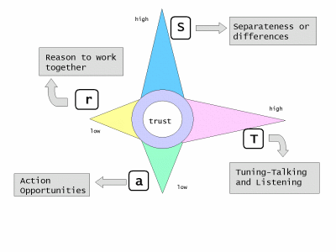
An AR relationship was one where two parties were collaborating to address a problem but the parties were almost “clones”. The employees had the same background and perspective. Although they had made time for “T”, talking and listening, because they had so few differences, there was little challenge of the status quo.
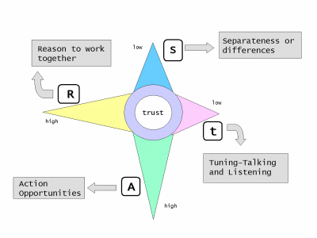
STARs can be fostered within organizations and between organizations. Especially in large organizations, the potential for internal STARs may be high as specialization between departments has increased the capacity for S (separateness or differences). In addition, downsizing may have reduced the time for T (talking and listening to challenge ideas.) Cross-functional task forces address S (separateness or differences) and T (talking and listening). They also make A (action) a requirement which makes R (reason to work together) obvious.
Relationships with lots of generative potential have four long points. In complex contexts, these need to be fostered and nurtured. However, there is a down-side. These long STARs require a heavy commitment of time. As time is a limited resource, it is important to recognize which STARs are more worthwhile. In addition, there is a need to develop STARs throughout the organization. They need to be distributed throughout the organization. Trying to centrally control all STARs limits the capacity of the whole organization.
Think about your current relationships at work - both inside the organization and outside the organization. What shape of STAR do you see in these relationships? Where do you need to further develop long STARs to address the complex contexts in your work?
Exercise One: Mapping current relationship STARs
Identify the key relationships that are engaged in this complex issue. Plot each on the STAR. (The relationships can be with individuals or institutions, and they can be either internal or external to the organization.)
Issue Relationship STAR

For each relationship, what needs to be done to enhance its generative potential?
To get you started, here are a few examples. The lower case letters in the word “STAR” represent the gaps or weaknesses in the relationship.
- A STaR, is a relationship with limited action opportunities. What is blocking the action opportunties? Is it a bureaucratic approval process or the need for a supervisor’s permission to act?
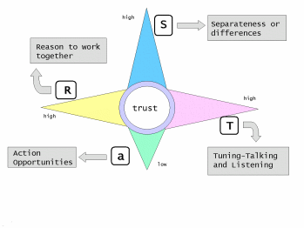
- A sTAR is missing separateness or differences. To enhance its capacity to generate new insights, products or services, new perspectives need to be brought into the relationship. This may require new participants or at least some structured creativity exercises to reveal hidden assumptions. Who could be added or dropped to enhance the differences in the group?
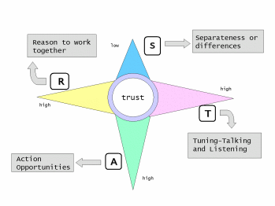
- A STar is all talk and no action. What is preventing the relationship from moving to action? Can you change this context?
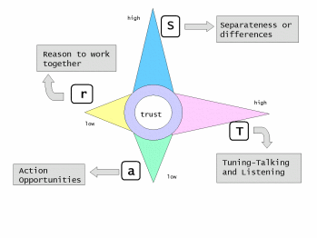
- A stAR has limited capacity for reflecting on the conceptual changes that are happening. So it may fail to recognize shifts in patterns and thus will expend resources on experiments without capitalizing on the learning from them.
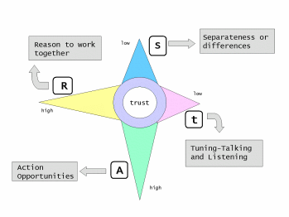
Relationship Type of STAR What needs to be done

Alternative to exercise one - Mapping potential relationship STARs
Do the same as exercise one but instead of identifying and mapping current relationships, identify potential relationships.
Issue Relationship STAR

References:
Lane, David and Robert Maxfield, “Strategy Under Complexity: Fostering Generative Relationships”, Long Range Planning, Vol. 29, No. 2, pp. 215-231, 1996
Zimmerman, Brenda J. and Bryan C. Hayday, “A Board’s Journey Into Complexity Science”, Group Decision Making and Negotiation, vol 8, pp. 281-303, 1999
Zimmerman, Brenda, and Curt Lindberg, Paul Plsek, Edgeware: Insights from Complexity Science for Health Care Leaders, VHA Inc., Irving, Texas, 1998 (pp. 155-160)

